**Project Design Phase-II**

**Data Flow Diagram & User Stories**

| Date | 13 April 2025 |
| --- | --- |
| Team ID | SWTID1743512004 |
| Project Name | FlightFinder |
| Maximum Marks | 4 Marks |

**Data Flow Diagrams:**

**SEE BELOW**

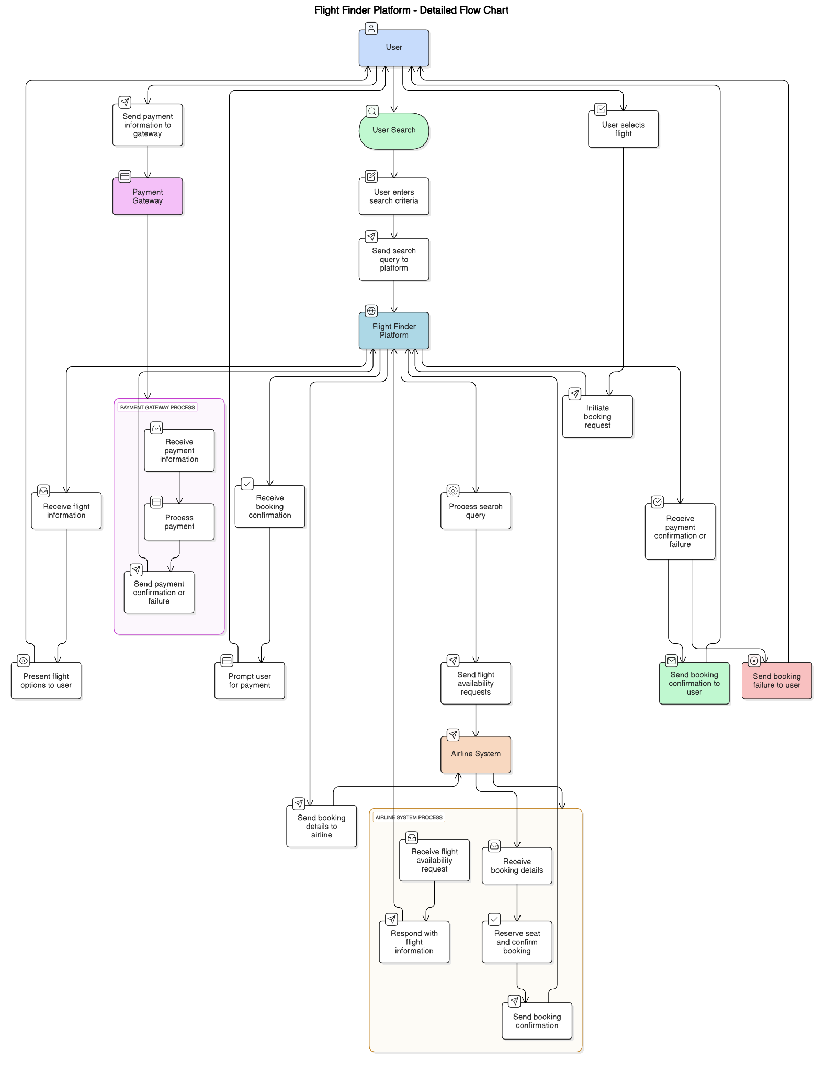

**User Stories**

Use the below template to list all the user stories for the product.

| **User Type** | **Functional Requirement (Epic)** | **User Story Number** | **User Story / Task** | **Acceptance criteria** | **Priority** | **Release** |
| --- | --- | --- | --- | --- | --- | --- |
| Customer (Web user) | Registration | USN-1 | As a user, I can register and log in to the application with my email and password. | I can create a new account and access my dashboard on the website. | High | Sprint-1 |
|  |  | USN-2 | As a user, I can receive a confirmation email after registration. | I receive a confirmation email and can verify my account. | Medium | Sprint-1 |
|  | Flight Search | USN-3 | As a user, I can search for flights by specifying departure city, arrival city, and date. | I can view a list of available flights that match my search criteria. I can filter flights by time, airline, and price. | High | Sprint-1 |
|  | Flight Selection & Booking | USN-4 | As a user, I can select a flight, enter passenger details, and book the flight. | I can view flight details, enter passenger information, review, and confirm my booking. | High | Sprint-1 |
|  | Booking Management | USN-5 | As a user, I can view and manage my bookings. | I can view my booking details, and I can modify or cancel my booking (if allowed). | High | Sprint-2 |
|  | Payment | USN-6 | As a user, I can pay for my flight booking securely. | I can complete the payment process and receive a confirmation. | High | Sprint-1 |
| Customer Care Executive | View/Manage Bookings | USN-7 | As a customer care executive, I can view and manage customer bookings | I can access booking details, and I can modify or cancel bookings. | High | Sprint-2 |
| Administrator | Flight Management | USN-8 | As an administrator, I can add, edit, and remove flights. | I can manage flight information (details, schedules, prices, availability). | High | Sprint-1 |
|  | User Management | USN-9 | As an administrator, I can manage user accounts. | I can create and manage accounts for customer care executives. | Medium | Sprint-2 |
|  | Reporting | USN-10 | As an administrator, I can generate booking reports. | I can view reports on booking data and statistics. | Low | Sprint-3 |
|  |  |  |  |  |  |  |
|  |  |  |  |  |  |  |